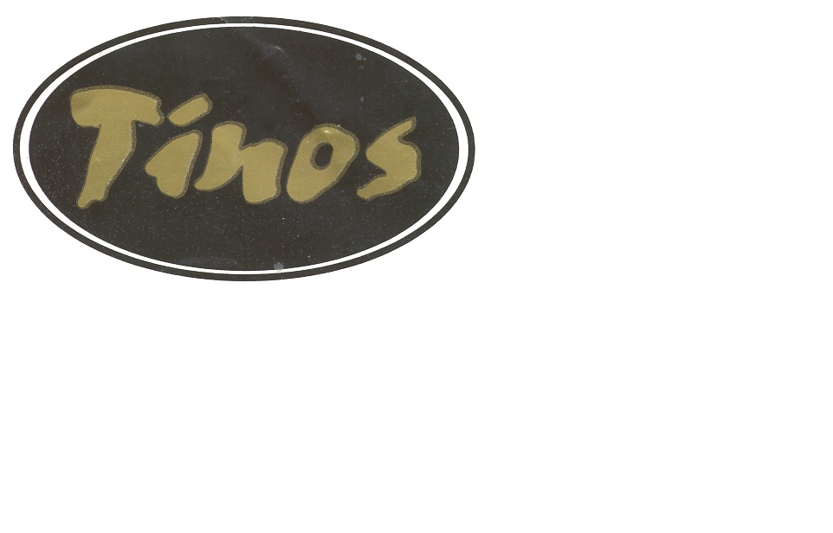
HILL STREET PRESTON PR1 2BB
TEL 01772 253888

Spaghetti alla Bolognese
Spaghetti cooked in a rich meat & tomato sauce

Lasagne al Forno
Layers of pasta with cheese and meat, tomato sauce & topped with cheese

Penne Arrabiata
Penne pasta with hot salami, mushrooms, onions, chilli & tomato

Pizza Margherita (V)
Pizza tomato and cheese

Pizza Capricccicosa
Pizza with tomato cheese ham & mushrooms

Pizza Vegatariana (V)
Pizza with tomato, peppers, onions & mushrooms

Pizza Calda
Tomato cheese hot salami & spicy beef

