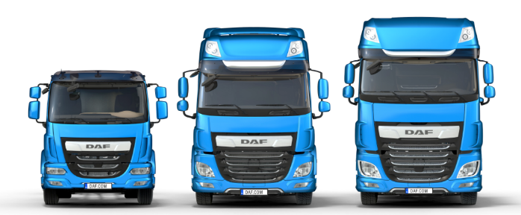
Application Form for an
Apprenticeship

PRIVATE AND CONFIDENTIAL
PLEASE COMPLETE IN BLOCK CAPITALS

Apprenticeship Applied For:

PERSONAL DETAILS

Surname Forename
Address Home Phone
Mobile
Email

Do you require a work permit to work in the UK? Yes No

It is unlawful to employ a person who does not have permission to work in the UK. Leyland Trucks will not be able to employ you if you cannot produce appropriate documentation when requested.

Why have you applied for an Apprenticeship with Leyland Trucks?

(You may like to include in your answer why you are interested in this specific apprenticeship; details of any practical projects or experiences you have; and any ideas for your future career.)

EDUCATION AND QUALIFICATIONS
School | From | To | Qualifications Obtained/Predicted (subject and grade e.g. GCSE)

College | From | To | Qualifications Obtained/Predicted (subject and grade e.g. A-Level / Degree)

Please give details of positions of responsibility held (Schools or Clubs)

WORK EXPERIENCE

Please complete the following section in date order beginning with your current or most recent employment.

Name & Address of Employer | From | To | Position Held and Duties Performed

SUPPORTING INFORMATION
Please give details of interests, hobbies and pastimes relevant to this role. (You could describe a time where you were determined to succeed):

Please detail the qualities you feel you possess that make you an ideal candidate for an apprenticeship at
Leyland Trucks:

Please describe what you anticipate to be the most beneficial aspects of undertaking this specific apprenticeship:

Please use this section to support your application by describing any particular skills, knowledge and experience you have gained and how they will assist you in your apprenticeship.

Any offer of employment is subject to us receiving two references which we deem satisfactory. You may give both references from your school / college, or one from school and one from an employer. Please give names, telephone numbers, email addresses and occupations of the two referees.
REFERENCES

Name:
Position:
Address:

Phone:
Email:

Name:
Position:
Address:

Phone:
Email:

CONDITIONS OF APPLICATION AND EMPLOYMENT

When you complete this form, you accept that employment with Leyland Trucks is subject to the following conditions:

• Satisfactory references will be required (see above)

• Passport or identification documents must be produced in compliance with
Home Office Legislation.

• An employment medical must be passed.

• Evidence of any relevant qualifications must be produced.

Declaration:
I certify that the information given on this application form including the Equal Opportunities Monitoring Form is correct. I understand that any willful omission or falsification may lead to the disqualification of this application or dismissal if
appointed.

Signed Date

RETURN COMPLETED FORMS TO:

Apprentice Recruitment  Leyland Trucks Ltd  Croston Road, Leyland, Lancashire  PR26 6LZ | Or | Leyland.Jobs@PACCAR.com

HOW WE STORE AND USE YOUR DATA

All or parts of the information on this form may be stored on computer files and used for the purpose of personnel administration, your future employment within the Company if successful, statistical and business analysis. If you are not successful for a position with the Company, your data will be stored for a period of 2 years after which it will be destroyed Such use will be subject to the provision of the Data Protection Act 2018 and relevant subsequent legislation.
Please complete this form in order to help us monitor Equal Opportunities in Employment. This form will be kept separate from your application form, and has no part in the selection process.
EQUAL OPPORTUNITIES MONITORING FORM

Surname Forename(s) Position Applied For
Gender Monitoring
Please tick appropriate box Male Female

Age Monitoring

Date of Birth

National

/ / Insurance No.

Ethnicity Monitoring
Please check the box which best describes your ethnic / cultural / racial origin:
WHITE MIXED ASIAN BLACK CHINESE British White & Black Caribbean Indian Caribbean Chinese English White & Black African Pakistani African
Scottish White & Asian Bangladeshi Other
Welsh Other Other
Irish
Other

DISABILITY MONITORING
Do you suffer with a disability as defined by the DDA, or a long term health condition?
Yes □ No □

What is the effect or impact of your disability or health condition?

Are there any reasonable adjustments that would need to be made?

Have you ever been convicted of a criminal offence (spent convictions do not need to be declared) under the
Rehabilitation of Offenders Act 1974?

(if yes please give information)
Yes □ No □

ASSEMBLY OPERATOR TRAINING SCHEME
About Leyland Trucks
Leyland Trucks is the UK’s largest commercial vehicle manufacturing business and produces nearly 15,000 trucks per year from its state-of-the-art facility in Lancashire.
The company is a division of the American corporation PACCAR Inc, a global technology leader in the design, manufacture and customer support of high-quality light, medium and heavy-duty trucks under the Kenworth, Peterbilt and DAF nameplates. It also provides financial services and information technology and distributes truck parts related to its principal business.
Since Leyland Trucks was acquired by PACCAR in 1998, it has become the group's established centre for light and medium truck design, development and manufacture.
Having the right people in the right place, with the right skills, at the right time is essential to our business success and our apprenticeship schemes help ensure we continue as market leader.
What We Are Looking For
With a keen, demonstrable interest in Automotive, Manufacturing or Engineering, you will be eager to learn and be able to adapt to a changing environment. With the ability to use your own initiative, you will take co-responsibility for your development within the business and help shape your future career.
GCSE grade 4 (C) or above in maths and English is essential.

Assembly Operative Apprenticeship
During this 1 year apprenticeship, you will gain first-hand knowledge how our trucks are assembled through the use of just-in-time manufacturing methods, correct tool usage and electronic work instructions. Working within a team to assemble our vehicles, you will work towards achieving your Performing Manufacturing Operations NVQ whilst completing a BTEC level 2 in Engineering on a block release basis at Preston’s College.
What happens after I finish the Assembly Operative Apprenticeship?
Following assessment and discussion, we will agree next steps with you which may include you progressing to a further apprenticeship:
Automotive Engineering Apprenticeship
Completing an additional 2 years whilst studying a higher level engineering qualification at Preston’s College on a block release basis, you will gain hands-on experience and an insight into areas including frame assembly, piping and wiring, chassis and cab assembly, and vehicle finish. You will undertake a level 3 automotive engineering NVQ, following a fitting pathway, which will expand your knowledge of vehicle assembly and manufacturing methods, and complete a BTEC level 3 in Engineering.
Benefits
A competitive starting salary of £14,483 rising during each year of the scheme; 33 days of holiday (which includes statutory holidays); a final salary pension and medical support schemes.

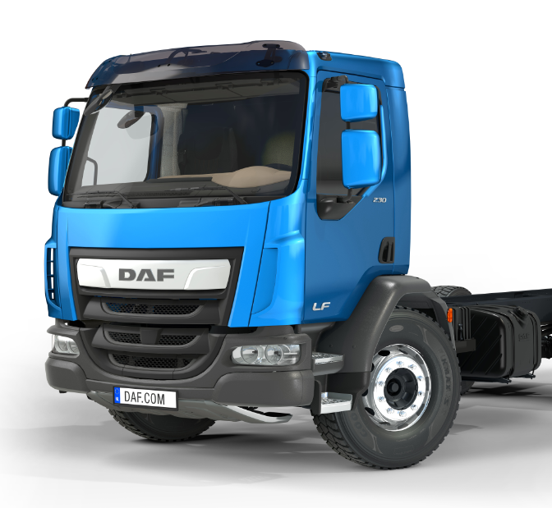
Application Proces
Apprentice application forms can be downloaded via the website: www.leylandtrucksltd.co.uk/en-gb/working-at-leyland-trucks/young-professionals#apprenticeships and emailed to: Leyland.jobs@PACCAR.com The closing date for applications is Friday 8th March, 2019.

AUTOMOTIVE ENGINEERING and MAINTENANCE APPRENTICESHIPS
Automotive Engineering Apprenticeship
Undertaking a structured rotation through various assembly departments, you will a complete a level 2 Performing Manufacturing Operations NVQ before studying towards a level 3 Automotive Engineering qualification. With practical hands-on experience you will gain an insight into areas including frame assembly, piping and wiring, chassis and cab assembly, vehicle finish and prototype.
During years 3 and 4, you will also have the opportunity to specialise in either a fitting pathway by gaining a greater understanding of truck assembly, or an auto-electrical pathway through expanding your knowledge of electrical fault finding, diagnostics and repair.
Maintenance Apprenticeship
As part of this apprenticeship, you will learn how to maintain the equipment and facilities necessary to keep the market leading truck factory at peak condition. Working as part of a multifunctional maintenance team you will learn how to carry out both scheduled and none scheduled mechanical maintenance on plant and equipment i.e cranes & lifting equipment, control systems, & pneumatic tooling
Completing an Engineering Maintenance NVQ, combined with a HNC, you will have the opportunity to follow a Mechanical or Electrical Maintenance pathway.
Benefits
A competitive starting salary of £14,051, rising during each year of the scheme; 33 days of holiday (which includes statutory holidays); a final salary pension and medical support schemes.

About Leyland Trucks
Leyland Trucks is the UK’s largest commercial vehicle manufacturing business and produces nearly 15,000 trucks per year from its state-of-the-art facility in Lancashire.
The company is a division of the American corporation PACCAR Inc, a global technology leader in the design, manufacture and customer support of high-quality light, medium and heavy-duty trucks under the Kenworth, Peterbilt and DAF nameplates. It also provides financial services and information technology and distributes truck parts related to its principal business.
Since Leyland Trucks was acquired by PACCAR in 1998, it has become the group's established centre for light and medium truck design, development and manufacture.
Having the right people in the right place, with the right skills, at the right time is essential to our business success and our apprenticeship schemes help ensure we continue as market leader.

What We Are Looking For
To apply, you will need a minimum of 5 GCSEs at grade 4 or above (A*-C), including maths, English and a science.
With a keen, demonstrable interest in Engineering, you will be eager to learn and be able to adapt to a changing environment. With the ability to use your own initiative, you will take co-responsibility for your development within the business and help shape your future career.

Application Proces
Apprentice application forms can be downloaded via the website: www.leylandtrucksltd.co.uk/en-gb/working-at-leyland-trucks/young-professionals#apprenticeships and emailed to: Leyland.jobs@PACCAR.com The closing date for applications is Friday 8th March 2019.

DESIGN ENGINEERING
About Leyland Trucks
Leyland Trucks is the UK’s largest commercial vehicle manufacturing business and produces nearly 15,000 trucks per year from its state-of-the-art facility in Lancashire.
The company is a division of the American corporation PACCAR Inc, a global technology leader in the design, manufacture and customer support of high-quality light, medium and heavy-duty trucks under the Kenworth, Peterbilt and DAF nameplates. It also provides financial services and information technology and distributes truck parts related to its principal business.
Since Leyland Trucks was acquired by PACCAR in 1998, it has become the group's established centre for light and medium truck design, development and manufacture.
Having the right people in the right place, with the right skills, at the right time is essential to our business success and our apprenticeship schemes help ensure we continue as market leader.
What We Are Looking For
To apply, you will need 96 UCAS points (new tariff system) and study an Engineering subject. You will also possess a minimum of 5 GCSEs at grade 4 or higher (grade A*-C), including maths, English and a science.
With a keen, demonstrable interest in Engineering, you will be eager to learn and be able to adapt to a changing environment. With the ability to use your own initiative, you will take co-responsibility for your development within the business and help shape your future career.

Design Engineering Apprenticeship
Leyland has sole responsibility for the engineering design and development of the DAF LF product within the PACCAR organisation. As an apprentice you will gain a significant amount of knowledge through undertaking a structured rotation through various mechanical and electrical design functions whilst studying towards a formal higher level qualification in your applicable engineering discipline. Gaining CAD skills and an insight into design areas including chassis, powertrain, cabs and electrical systems, you will acquire the skills and knowledge necessary to undertake the role of an engineer upon completion of this scheme.
Benefits
A competitive starting salary of £14,051 rising during each year of the scheme; 33 days of holiday (which includes statutory holidays); a final salary pension and medical support schemes.
Application Process
Apprentice application forms can be downloaded via the website: www.leylandtrucksltd.co.uk/en-gb/working-at-leyland-trucks/young-professionals#apprenticeships and emailed to: Leyland.jobs@PACCAR.com
The closing date for applications is Friday 8th March, 2019.

