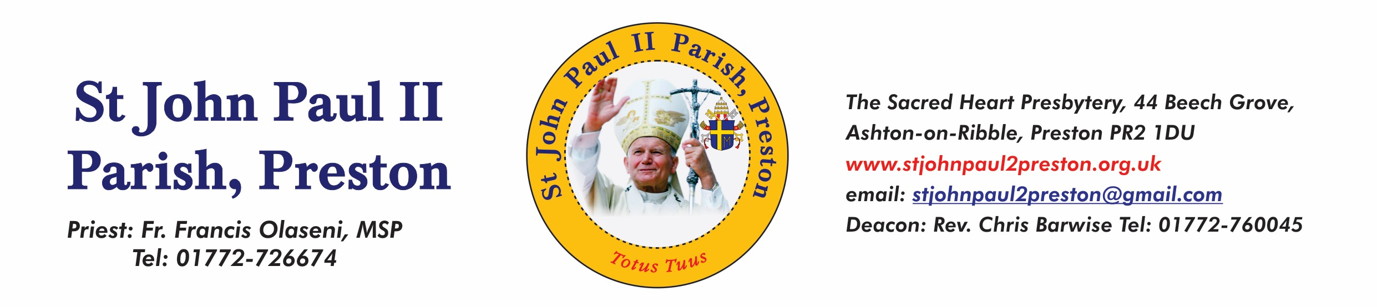

Sept 27th 2021.

Dear parents and candidates for Confirmation,

As you are aware, our Confirmation preparation programme had to be suspended due to Covid 19.

We are now in a position to continue preparing our young people for the sacrament of Confirmation. It will be a great joy to see our young candidates complete the journey they started.

We will be holding 3 sessions prior to Confirmation on 23rd November 2021. Please note that the Sessions are not optional.

19th October 6:00 – 7:30 Session 1 Recap (Mia Barlow)
2nd November 6:00 – 7:30 Session 2 Prayer (Deacon Chris)
16th November 6:00 Sacrament of Reconciliation (Father Francis)
23rd November 6:30pm Confirmation (Bishop Paul).

We look forward to seeing all our young people again.

Father Francis & the Confirmation Team

