Guys Farm, Lancaster, Bay Horse, Lancashire LA2 9DF
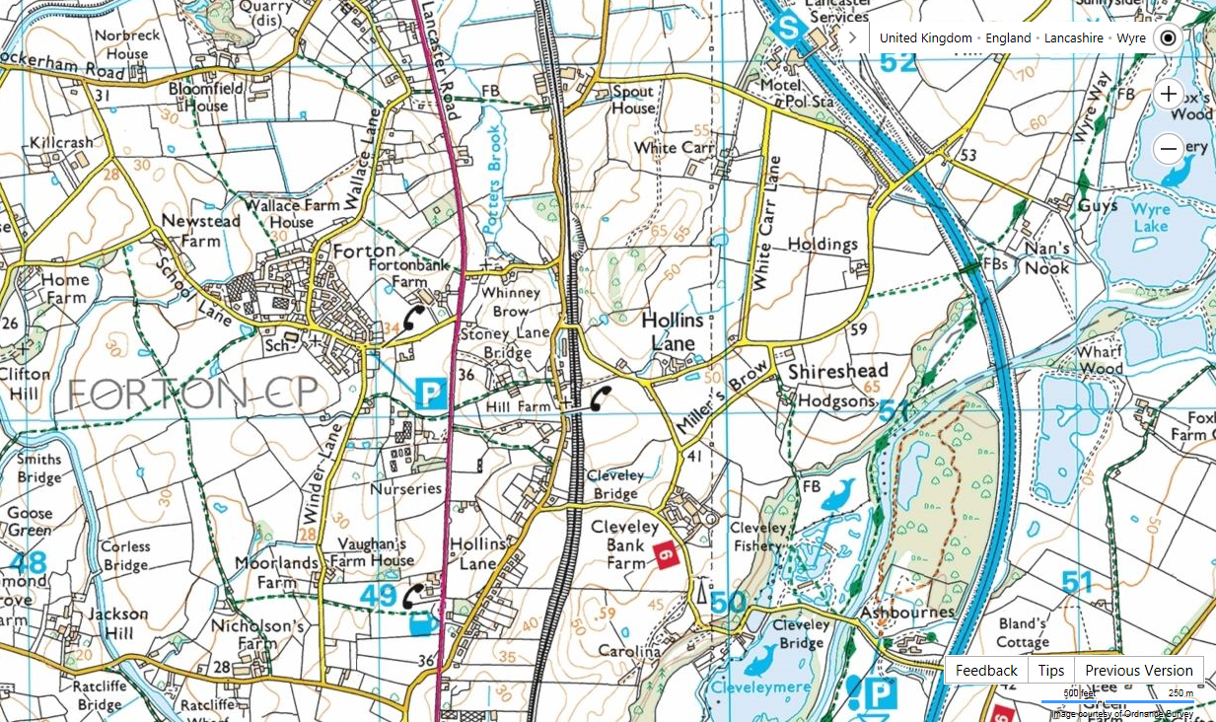
If travelling from the South on the A6, approximately 2¾ miles North of Garstang, turn right into Hollins Lane, continue under the Railway Bridge and turn first right, continue to the T junction at the end and turn left over the motorway, turn Immediately right and Guy’s Farm is at the end of the lane.
CAUTION, there may be large vehicles from the adjacent property manoeuvring in the lane.
If travelling from The North on the A6 or M6 junction 33, take A6 south from roundabout, take 2nd turning on left, signed to Trough of Bowland, then 1st left under railway bridge and then 3rd left passing motorway service area, turn left at T junction, over the motorway, then immediate right and Guy’s Farm is at the end of the lane.
CAUTION, there may be large vehicles from the adjacent property manoeuvring in the lane.
Kit List
 | Below is a kit list. Students need to think carefully about what they pack as it all has to fit into their rucksack (remember they also have a tent, stove and food to pack as well) and they have to carry it for two days. Students need to ensure that they have enough kit to keep them comfortable for two days as the weather can change rapidly so just because it is warm the morning they leave doesn't mean that it won't rain on the expedition! You do not have to go out and buy expensive new kit you will probably have a lot of the items listed below at home. Students should do their own packing as part of the learning process. All kit will be brought to school and checked prior to the expedition on the evening of the 29th June 3.30-4.30. Please note any item marked with an * can be borrowed from school.
 | Clothing |  |  | Personal Kit
 | Item |  |  | Toothbrush and paste
 | Walking boots (with ankle support and good sole) |  |  | Hairbrush
 | Thick Socks |  | * | Sleeping bag
 | T-shirt |  | * | Rucksack
 | Thermal Top |  |  | Roll Mat
 | Jumper |  |  | Torch
 | Trousers (not jeans) |  |  | Notebook and pencil
 | Shorts (if warm weather forecast) |  |  | Spare laces
 | Nightwear |  |  | Knife, fork, spoon
 | Underwear |  |  | Plate
 | Hat and sunhat (if warm) |  |  | Mug
 | Gloves |  |  | Small towel
 | Waterproof Coat |  |  | Water Bottle 2L or 2x1L
 | Waterproof Trousers |  |  | 2 x Bin bags
 |  |  |  | Personal medication eg inhaler
 | Shared between the group
 | Insect repellent
 | Sun cream
 | Plastic bags- for rubbish
 | Camera (optional)
 | Scourer
* | Stove
* | Tent
 | Small first aid kit (Blister plasters etc.)

